Trinity Sunday

ORDER OF WORSHIP
10:00 a.m.

Sunday, June 12, 2022 Seasonal Color: White

WE GATHER IN GOD’S NAME

Chiming of the Hour

Welcome and Announcements
(Please take a moment to silence your cell phones and electronic devices. And, with the gift of music, let us prepare our hearts, minds, and souls
for this special time with God and with one another.)

Prelude: “Praise God from Whom All Blessings Flow” arr. Pachelbel

(Please stand in body or spirit and let us join together in the Call to Worship)

*Call to Worship:

O God, your name is majestic in all the earth;

Your glory is chanted above the heavens.

You have crowned your people with glory and honor;

We give you all praise in response to your grace.

Let us worship God!

*Prayer of Praise and Adoration

Creator God, the earth is yours and all who dwell therein; the moon and stars reflect your radiance. You are the potter who fashions works of beauty from the mud, the painter who hangs the rainbow in the sky as the sign of your covenant. We join with those through the ages who have lauded your works of creation and redemption, evermore praising you and saying, “How majestic is your name in all the earth!”

*Opening Hymn: “Holy, Holy, Holy! Lord God Almighty!” GTG # 1

(During the singing of the hymn, worshipers are invited to bring their 5¢-a-Meal offering forward as an act of worship, and place them in the containers in front of the sanctuary.)

WE ARE RENEWED IN GRACE

*Prayer of Confession:
God of justice and love, you take away the sin of the world; have mercy upon us as we confess our sin. We call you God of creation, yet we serve idols of our own making. We confess Christ as our Savior, yet we rely on elaborate security systems for our protection. We claim the indwelling Spirit, yet we abide by our own counsel. Forgive our double-mindedness, and through Christ make us whole.

*Assurance of Pardon

*Congregational Response: “Glory Be to the Father” GTG #581
Glory be to the Father, and to the Son, and to the Holy Ghost;
As it was in the beginning, is now, and ever shall be,
World without end. Amen, Amen.

WE RECEIVE GOD’S WORD

Anthem: “We Believe” Travis Ryan, Matthew Hooper and Richie Fike
In this time of desperation when all we know is doubt and fear,
There is only one foundation: We believe, we believe.
In this broken generation when all is dark, You help us see.
There is only one salvation: We believe, we believe.

(refrain) We believe in God the Father. We believe in Jesus Christ.
We believe in the Holy Spirit, and He’s given us new life.
We believe in the crucifixion. We believe that He conquered death.
We believe in the resurrection, and He’s coming back again.
We believe.

So let our faith be more than anthems, greater than the songs we sing.
In our weakness and temptations we believe, we believe. (refrain)
Let the lost be found, let the dead be raised;
In the here and now let love invade. Let the church live loud!
Our God, we’ll say, “We believe! We believe!
And the gates of hell will not prevail,
For the pow’r of God has torn the veil.
Now we know Your love will never fail. We believe! We believe!
(refrain)

Time for Young Disciples Laura Sparks

Prayer of Illumination
Shine on us, loving God, the pure light of your holy gospel, that we may see and understand your truth, and apply it in our lives; in Jesus’ name Amen.

Scripture: Proverbs 8:1-4; 22-31 pg.590, 591

Sermon: “Father, Son and Holy Ghost!” David Roquemore

*Hymn: “All Hail the Power of Jesus’ Name!” GTG #263

WE RESPOND TO GOD’S GRACE

*Affirmation of Faith: Book of Common Worship
We believe there is no condemnation for those who are in Christ Jesus; for we know that all things work together for good and for those who love God, who are called according to God’s purpose. We are convinced that neither death, nor life, nor angels, nor rulers, nor things present, nor things to come, nor powers, nor height, nor depth, nor anything else in all creation, will be able to separate us from the love of God in Christ Jesus our Lord. Amen.

Prayers of the People and the Lord’s Prayer
Our Father, who art in heaven, hallowed be thy name, thy kingdom come, thy will be done, on earth as it is in heaven. Give us this day our daily bread; and forgive us our debts, as we forgive our debtors; and lead us not into temptation, but deliver us from evil. For thine is the kingdom, and the power, and the glory, forever. Amen.

*Doxology: “Praise God from Whom All Blessings Flow” GTG # 606
Praise God from whom all blessings flow;
Praise Him all creatures here below;
Praise Him above, ye heavenly host;
Praise Father, Son and Holy Ghost. Amen.

Offering Our Gifts

*Prayer of Dedication:
We bring these offerings to you, O God, and offer our lives as well, so that your work may continue and flourish in Jesus’ name, Amen.

WE LEAVE TO SERVE

*Closing Hymn: : “Come, Thou Almighty King” GTG #2

*Benediction

*Postlude: “Awake the Trumpet’s Lofty Sound” G. F. Handel/arr. Hal Hopson

(* Please stand in body or spirit.)

Copyright information for today’s service music:
“Praise God from Whom All Blessings Flow”, arr. Johann Pachelbel, public domain; “Holy, Holy Holy! Lord God Almighty!”, text Reginald, music John Bacchus Dykes, public domain; arr. and descant “Nicaea” from The Coral Ridge Festival Hymn Collection, Vol. 1, Samuel Metzger, copyright ©2009 Birnamwood Publications (ASCAP), div. of Morningstar Music Publishers, Inc. St. Louis, MO, OneLicense.net 701800-A; “We Believe”, text and music Travis Ryan, Matthew Hooper and Richie Fike, copyright © 2013 Abundant Life Ministries UK (PRS), Travis Ryan Music (ASCAP) Integrity Worship Music (ASCAP) and Integrity’s Praise! Music (BMI) CCLI # 6367165, CCLI #20260412; “All Hail the Power of Jesus’s Name”, text and music public domain; descant Michael E. Young, copyright ©1979 GIA Publications, Inc., Chicago, IL, OneLicense.net 701800-A; “Praise God from Whom all Blessings Flow”, traditional public domain; “Come, Thou Almighty King”, text Collection of Hymns for Social Worship, music Felice de Giardini, public domain; arr. and descant “Italian Hymn” from The Coral Ridge Festival Hymn Collection, Vol. 1, Samuel Metzger, copyright ©2009 Birnamwood Publications (ASCAP), div. of Morningstar Music Publishers, Inc. St. Louis, MO, OneLicense.net 701800-A; “Awake the Trumpet’s Lofty Sound”, music G. F. Handel, arr. Hal Hopson, copyright © 2006 Hope Publishing Co., Carol Stream, IL, OneLicense.net 701800-A.

THE MINISTERS
All Members of First Presbyterian Church

THE MINISTRY STAFF
Laura Sparks – Director of Children, Youth and Family Ministry
lsparks@fpcnewton.com
Catherine C. Murdock – Music Director
Susan A. Strickland – Organist

ADMINISTRATIVE STAFF
Kim J. Berry – Office Manager
kberry@fpcnewton.com
Jim Ten Kate - Treasurer
Bill Inscoe - Treasurer Emeritus

MISSIONARIES OF THE CHURCH
Lawrence & Inge Sthreshley – Congo
Rev. Dr. John McCall - Taiwan

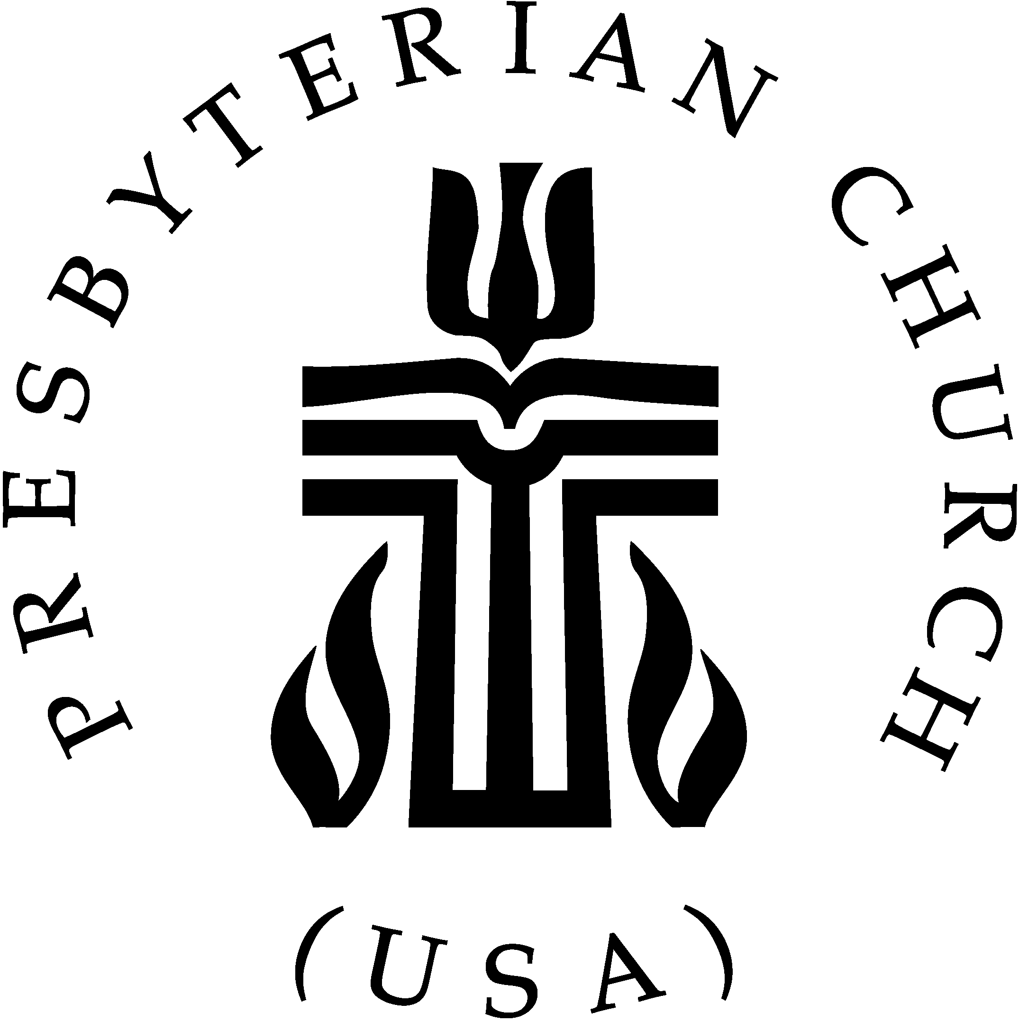

THE SESSION
Class of 2022 Class of 2023 Class of 2024
Deward Clark (2) Brenda Eckard (8) Gary McDougal (5)
Charles Davis (6) Suzanne Rhinehart (4,6) Charles Moody (2)
Karen Mills (1) Randy Williams (7) Amy Owensby (3)
Amy Yenderusiak (4)

(1) Worship (5) Christian Education
(2) Property (6) Congregational Ministries
(3) Personnel (7) Missions
(4) Finance (8) Membership & Evangelism

Suzanne Rhinehart - Clerk of Session

PASTOR
Rev. Dr. David Roquemore

Pastor David Roquemore may be reached at:
828-464-06485 (Church) droquemore@fpcnewton.com
704-325-3916 (Home) 717-512-2779 (Cell)

FIRST PRESBYTERIAN CHURCH
Serving the Newton-Conover area since 1858
Partners with Iglesia El Redentor, Guatemala

Sunday, June 12, 2022
Trinity Sunday
10:00 a.m.

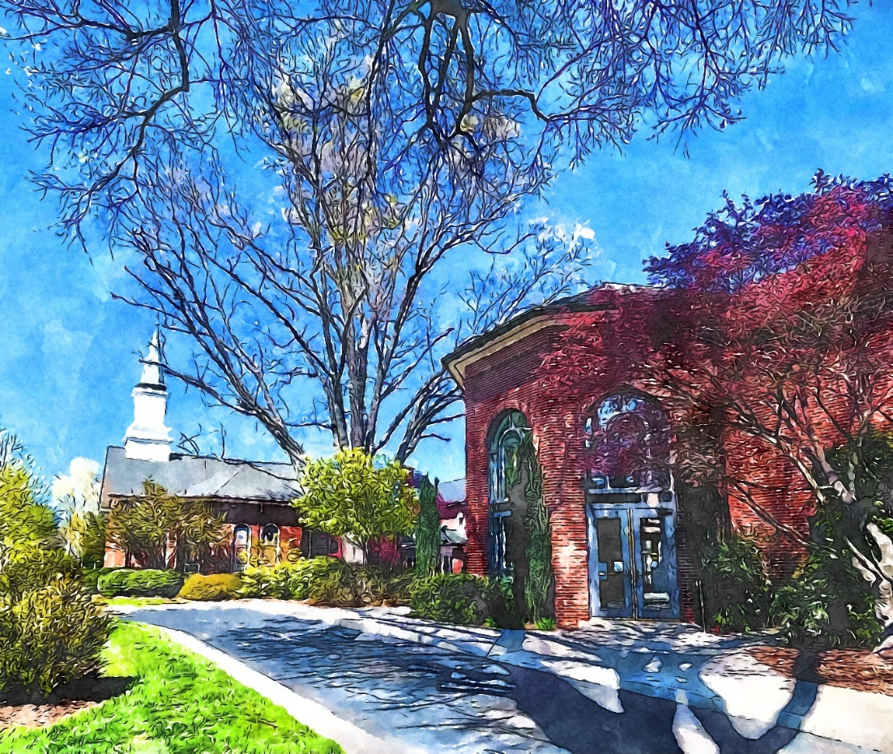

701 N. Main Avenue Newton, NC 28658
(828) 464 – 0648 www.fpcnewton.org

MISSION STATEMENT:

Following Christ together in witness, love and service.

