2nd Sunday after Pentecost

ORDER OF WORSHIP
10:00 a.m.

Sunday, June 19, 2022 Seasonal Color: Green

WE GATHER IN GOD’S NAME

Chiming of the Hour

Welcome and Announcements
(Please take a moment to silence your cell phones and electronic devices. And, with the gift of music, let us prepare our hearts, minds, and souls
for this special time with God and with one another.)

Prelude:
“Faith of our Fathers” Hemy/Walton/arr. Michael Burkhardt

(Please stand in body or spirit and let us join together in the Call to Worship)

*Call to Worship

Your love, O God, extends to the heavens;

your righteousness is like the ever-rolling mountains.

We shall feast on the abundance of your goodness, O God,

and drink our fill of your mercy. O Fountain of life.

Let us worship God!

*Prayer of Praise and Adoration

O God of light and truth, lead us by your Word to your holy hill and to your dwelling. Then we shall come to your altar with exceedingly joy and praise you with the lyre, for you are God. The wind cannot contain you, nor the fires consume you; the earthquake fails to encompass your power, for you are God. Speak as you have spoken with your still and small voice, and we shall hear and be your people.

*Opening Hymn: “Praise to the Lord, the Almighty” GTG # 35

WE ARE RENEWED IN GRACE

*Prayer of Confession
Infinite Word of truth, breathe upon us the refreshing breath of your Holy Spirit and forgive our transgressions. Cleanse our hearts of false doctrine by winds of righteousness and truth. Purge us by the fires of your eternal judgment and we shall be pure. Shake the foundations of our jealousy and selfishness and cast us anew in the image of Christ Jesus.

*Assurance of Pardon

*Congregational Response
“Hear the Good News of Salvation” (vs 1) GTG # 441
Hear the good news of salvation: Jesus died to show God’s love.
Such great kindness! Such great mercy! Come to us from heaven above.
Jesus Christ, how much I love you! Jesus Christ, you save from sin!
How I love you! Look upon me. Love me still and cleanse within.

WE RECEIVE GOD’S WORD

Anthem: “As the Deer” Martin Nystrom/arr. Douglas Wagner
As the deer pants for the water, so my soul longs after you;
You alone are my heart’s desire and I long to worship you.

(refrain) You alone are my strength, my shield,
To you alone may my spirit yield.
You alone are my heart’s desire, and I long to worship you.

I want you more than gold or silver, only you can satisfy;
You alone are the real joy-giver and the apple of my eye. (refrain)

You’re my friend and you are my brother, even though you are a king;
I love you more than any other, so much more than anything! (refrain)

And I long to worship you. For my soul longs for you.

Time for Young Disciples Laura Sparks

Prayer of Illumination
Guide us, O God, by your Word and Spirit, that in your light we may see light, in your truth find freedom, and in your will discover your peace; through Jesus Christ, our Lord. Amen.

Scripture: 1 Kings 19:1-15 pg. 326

Sermon: “When You Just Want to Stop” David Roquemore

*Hymn: “There Is a Place of Quiet Rest” GTG #824

WE RESPOND TO GOD’S GRACE

COMMISSIONING SUMMER YOUTH/ADULT TRIP PARTICIPANTS
Cedar Creek Mission Trip (June 19-24)
Laura Sparks, Margy Butterfield, Ray Rhinehart, Preston Inscoe, Tyler Inscoe, Will Eneix, Mason Nolley, Payton Nolley, Stephanie Ramirez, Kynsea Pugh, Sarah Butterfield

*Affirmation of Faith: The Apostles' Creed
I believe in God the Father, Almighty, Maker of heaven and earth, and in Jesus Christ his only Son our Lord: who was conceived by The Holy Ghost, born of the Virgin Mary, suffered under Pontius Pilate, was crucified, dead, and buried; he descended into hell; the third day he rose again from the dead; he ascended into heaven, and sitteth on the right hand of God the Father Almighty; from thence he shall come to judge the quick and the dead. I believe in the Holy Ghost; the holy catholic church; the communion of saints; the forgiveness of sins; the resurrection of the body; and the life everlasting. Amen.

Prayers of the People and the Lord’s Prayer
Our Father, who art in heaven, hallowed be thy name, thy kingdom come, thy will be done, on earth as it is in heaven. Give us this day our daily bread; and forgive us our debts, as we forgive our debtors; and lead us not into temptation, but deliver us from evil. For thine is the kingdom, and the power, and the glory, forever. Amen.

*Doxology: “Praise God from Whom All Blessings Flow” GTG # 606
Praise God from whom all blessings flow;
Praise Him all creatures here below;
Praise Him above, ye heavenly host;
Praise Father, Son and Holy Ghost. Amen.

Offering Our Gifts

*Prayer of Dedication
God of steadfast love, you give to each a measure of your bounteous mercy; accept what we offer in return as a gift of love from your family here. If it is service, make is pleasing to your sight. If it is wisdom, let it lead others to worship you alone. If it is dollars, multiply their effectiveness Do this for the sake of Christ, whose gift of himself has made us one.

WE LEAVE TO SERVE

*Closing Hymn: “God of the Sparrow” GTG #22
*Benediction

*Postlude: “Allegro” Henry Purcell/arr. Hal Hopson

(* Please stand in body or spirit.)

Copyright information for today’s service music:
“Faith of Our Fathers”, Hemy/Walton, arr. Michael Burkhardt, copyright © 2007 Birnamwood Publications (ASCAP) div of MorningStar Music Publishers, Inc. St. Louis, MO, OneLicense.net 701800-A; “Praise Ye the Lord, the Almighty”, text Joachim Neander, trans. Catherine Winkworth, music Stralsund Emewerten Gesangbuch; public domain; “Hear the Good News of Salvation”, music Wyeth’s Repository of Sacred Music, public domain; text Native American (Dakota); John B. Renville, trans. Emma Tibbets,1955, verse Jane Parker Huber, English trans metrical version © 1989 Jane Parker Huber (admin. Westminster John Knox Press), OneLicense.net 701800-A; “As the Deer”, text and music Martin Nystrom, © 1984 Universal Music-Brentwood Benson Publishing, arr. Douglas Wagner, © 2001 Maranatha Praise, Inc. (Admin by The Copyright Co., Nashville, TN) CCLI #1431, CCLI# 20260412; “Near to the Heart of God”, text and music Cleland Boyd McAfee, public domain; “Praise God from Whom all Blessings Flow”, traditional public domain; “God of the Sparrow”, text Jaroslav J. Vajda, © 1983 Concordia Publishing House; music Carl F. Schalk, © 1983 GIA Publications, Inc., Chicago, IL; “Allegro”, Henry Purcell, arr. Hal Hopson, copyright © 2006 Hope Publishing Co., Carol Stream, IL; OneLicense.net 701800-A.

THE PEACE CANDLE: The smaller, glass candle on the Communion table is a peace candle, and here is the candle’s story and meaning.
In 1986, a group of Americans attended a Russian Orthodox worship service. At the close of the service, an elderly woman pressed a three-ruble note into the hand of a Presbyterian pastor (only about $5 in American dollars, but a significant gift for this elderly woman). The woman asked him to buy a candle with it, and light that candle in his church as a symbol for peace. That Presbyterian pastor purchased a candle with the money, placed it on the Communion table in his sanctuary, and lit it during each worship service. Then the church bought other candles, in glass containers, and sent them to other churches with the request that they be lit during their worship services, as a symbol of our common hope for peace.
These peace candles have since spread across our world and across denominations. Our congregation received our peace candle on Sunday, November 16th, 2014. And, we have shared a candle with our sister church of El Redentor in Guatemala. Together with sisters and brothers in Guatemala and around the world, we light our candles every time we worship to remind us to pray for peace in our lives, in our communities, and in our world.

THE MINISTERS
All Members of First Presbyterian Church

THE MINISTRY STAFF
Laura Sparks – Director of Children, Youth and Family Ministry
lsparks@fpcnewton.com
Catherine C. Murdock – Music Director
Susan A. Strickland – Organist

ADMINISTRATIVE STAFF
Kim J. Berry – Office Manager
kberry@fpcnewton.com
Jim Ten Kate - Treasurer
Bill Inscoe - Treasurer Emeritus

MISSIONARIES OF THE CHURCH
Lawrence & Inge Sthreshley – Congo
Rev. Dr. John McCall - Taiwan

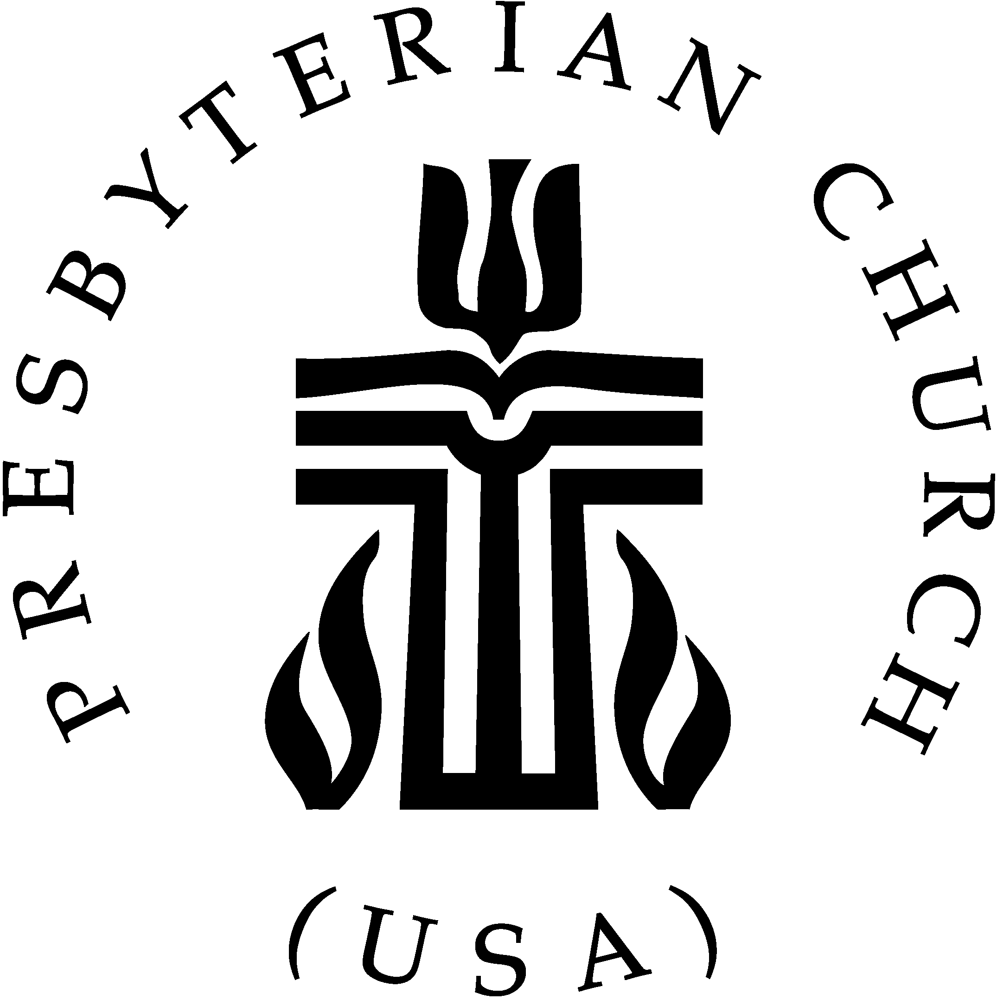

THE SESSION
Class of 2022 Class of 2023 Class of 2024
Deward Clark (2) Brenda Eckard (8) Gary McDougal (5)
Charles Davis (6) Suzanne Rhinehart (4,6) Charles Moody (2)
Karen Mills (1) Randy Williams (7) Amy Owensby (3)
Amy Yenderusiak (4)

(1) Worship (5) Christian Education
(2) Property (6) Congregational Ministries
(3) Personnel (7) Missions
(4) Finance (8) Membership & Evangelism

Suzanne Rhinehart - Clerk of Session

PASTOR
Rev. Dr. David Roquemore

Pastor David Roquemore may be reached at:
828-464-06485 (Church) droquemore@fpcnewton.com
704-325-3916 (Home) 717-512-2779 (Cell)

FIRST PRESBYTERIAN CHURCH
Serving the Newton-Conover area since 1858
Partners with Iglesia El Redentor, Guatemala

Sunday, June 19, 2022
2nd Sunday after Pentecost
10:00 a.m.

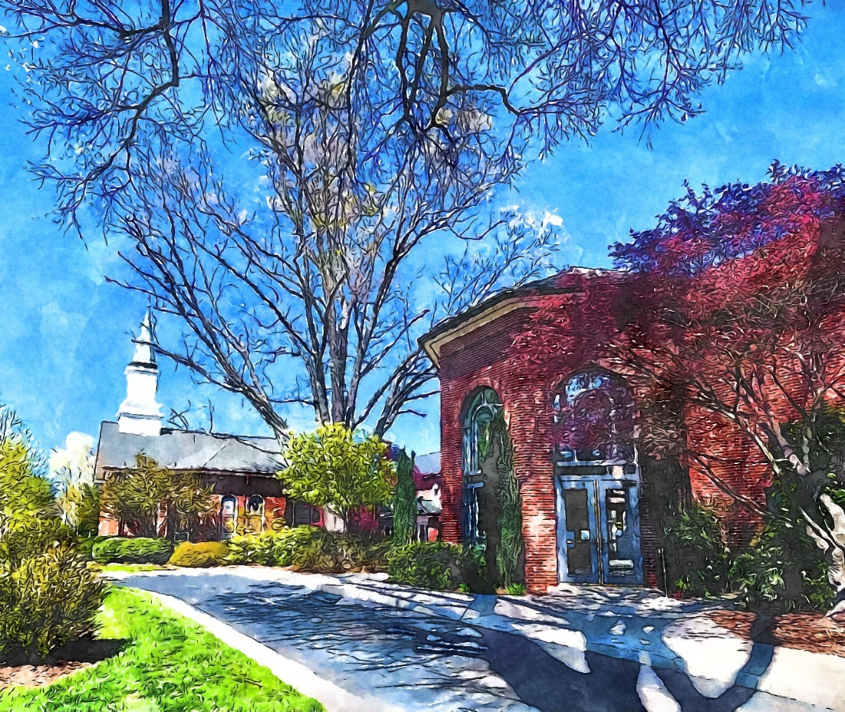

701 N. Main Avenue Newton, NC 28658
(828) 464 – 0648 www.fpcnewton.org

MISSION STATEMENT:

Following Christ together in witness, love and service.

